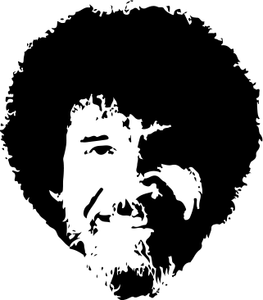

There is immense joy in just watching - watching all the little creatures in nature. Think about a cloud. Just float around and be there. Water's like me. It's laaazy ... Boy, it always looks for the easiest way to do things We tell people sometimes: we're like drug dealers, come into town and get everybody absolutely addicted to painting. It doesn't take much to get you addicted. Use what happens naturally, don't fight it. Trees get lonely too, so we'll give him a little friend.

Everything's not great in life, but we can still find beauty in it. We don't have to be committed. We are just playing here. You don't have to be crazy to do this but it does help. You can create beautiful things - but you have to see them in your mind first.

The secret to doing anything is believing that you can do it. Anything that you believe you can do strong enough, you can do. Anything. As long as you believe. You're meant to have fun in life. In nature, dead trees are just as normal as live trees.

All you need to paint is a few tools, a little instruction, and a vision in your mind. Only think about one thing at a time. Don't get greedy. Let's do it again then, what the heck. It's important to me that you're happy. The only prerequisite is that it makes you happy. If it makes you happy then it's good.

There it is. All kinds of happy little splashes. We don't need any guidelines or formats. All we need to do is just let it flow right out of us. You can do anything your heart can imagine. Don't be afraid to make these big decisions. Once you start, they sort of just make themselves. We artists are a different breed of people. We're a happy bunch.

I'll go over the colors one more time that we use: Titanium white, Thalo green, Prussian blue, Van Dyke brown, Alizarin crimson, Sap green, Cad yellow, and Permanent red. Maybe there's a happy little Evergreen that lives here. You have to make almighty decisions when you're the creator. Trees grow however makes them happy. Maybe there's a little something happening right here. Let's have a little bit of fun today.

Even trees need a friend. We all need friends. Do an almighty painting with us. If it's not what you want - stop and change it. Don't just keep going and expect it will get better. Only God can make a tree - but you can paint one. Trees grow in all kinds of ways. They're not all perfectly straight. Not every limb is perfect. Isn't it great to do something you can't fail at?